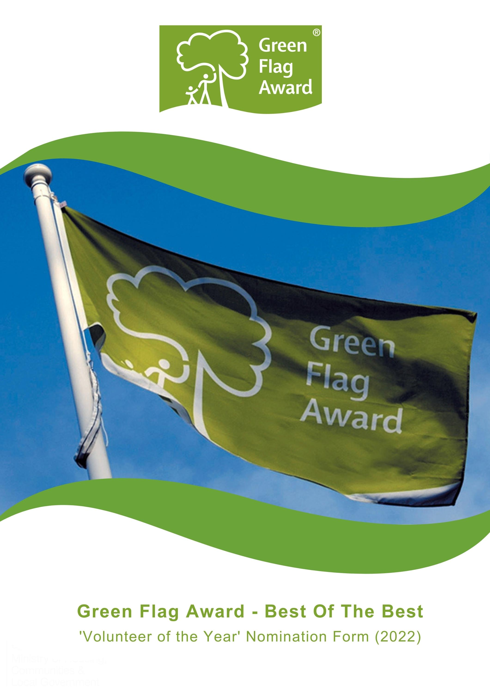

The Green Flag Award Scheme is the UK standard for parks and green spaces. The Scheme is delivered in the UK by Keep Britain Tidy, Keep Northern Ireland Beautiful, Keep Scotland Beautiful and Keep Wales Tidy.
To highlight the amazing work that takes place in our award-winning green spaces we are celebrating the ‘Best of the Best’ in our annual virtual award ceremony this November.
Nominees will be shortlisted in October 2022 and the winner will be announced during the virtual award ceremony, on Tuesday 15th November 2022.

Award Category: Volunteer of the Year
Eligibility
Volunteers are considered to be individuals who are not paid for their service or contribution to the community (apart from any eligible out-of-pocket expenses)
Who can be nominated?
To be eligible for an award, the volunteer must be endorsed by the organisation for which they volunteer. The individual must have been involved in on one of the Green Flag Award winning sites in the UK.
Who can nominate?
Any individual is entitled to nominate any number of volunteers. However, any nomination must be endorsed by the organisation for which the person volunteers.
Criteria
The following criteria will be considered by the selection panel:
- Scope of the work undertaken and the outcome of their volunteer achievement
- Initiative and innovation demonstrated by the volunteer
- Impact and benefit the individual has made in the course of their volunteering in their local community
- Any obstacles which the nominee may have had to overcome to achieve the outcomes of their volunteer work.
Nominations must be submitted electronically and address the criteria for the award. Organisations may nominate more than one volunteer.
Nominees must agree to any media publicity and promotion associated with the award as requested by The Green Flag Award Scheme and or Keep Britain Tidy and their partners.

Selection Panel
Nominations will be assessed by an independent selection panel chaired by the Green Flag Award Team.
The judges reserve the right not to confer an award.
Award
The panel will award a winner, or in a tie, may award joint winners of the award. In exceptional circumstances the panel may confer a special commendation.
Feedback
The selection panel will provide feedback for the winner of the award. No feedback will be provided to unsuccessful applications
If you would like to send us supporting evidence such as reference materials, photos, screen grabs or press cuttings, please send these with the completed application form to greenflagawards@keepbritaintidy.org
CLOSING DATE FOR ENTRIES: Friday, 30th September by 5pm

Part One:
Project and applicant Information
Name of nominated volunteer

Contact details of nominated volunteer
Name, address, tel, email

Name and contact details of person and organisation nominating the volunteer

Name of Green Flag Award site

Name of person and organisation endorsing the nomination (if different to person making the nomination)

Please complete each of the sections below, using maximum 500 words per section and identify any supporting evidence you are submitting.

Part Two:
Application Details
What work did the volunteer undertake and what did they achieve?
(Maximum 500 words, please identify any supporting evidence you are submitting.)

Tell us about initiative and innovation demonstrated by the volunteer.
(Maximum 500 words, please identify any supporting evidence you are submitting.)

Describe what impact and benefit the individual has made in the course of their volunteering.
(Maximum 500 words, please identify any supporting evidence you are submitting.)

Tell us about any obstacles which the nominee may have had to overcome to achieve the outcomes of their work.
(Maximum 500 words, please identify any supporting evidence you are submitting.)

Thank you for submitting your application.

