Green Flag Award Score Sheet 2023 | 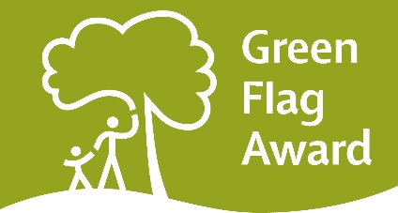

Scoring line

0 1 | 2 3 4 | 5 6 | 7 | 8 | 9 | 10
Very Poor | Poor | Fair | Good | Very Good | Excellent | Exceptional

Name of green space

Managing authority

Judge(s)

Date of desk assessment

Date of field assessment

Scoring

- Each category must be scored out of 10
- Work out the average score for desk assessment and multiply by 3 (score out of 30)
- Work out the average for field assessment and multiple by 7 (score out of 70)
- By adding the two scores together you will get a final mark
- For a site to pass each section they must reach a minimum of 15 on the desk assessment and 42 on the field assessment.
- An overall score of 66 must be scored for a site to achieve Green Flag Award status
- Rounding up or down of numbers must be done at the very end of each assessment, when you multiply the average.

Strengths & recommendations

- Comments and recommendations must be included against each category in the feedback sections. They should be detailed enough to provide constructive information to applicants

Final score

Desk assessment (minimum 15) |  | Field assessment (minimum 42)
Total score |  | Green Flag Awarded?

Field Assessment

A Welcoming Place | Score |  | Biodiversity, Landscape and Heritage | Score
1 Welcoming |  |  | 19 Management of natural features, wild flora and fauna
2 Good and safe access |  |  | 20 Conservation of landscape features
3 Signage |  |  | 21 Conservation of buildings & structures
4 Equal access for all

 |  |  | Community Involvement
Healthy, Safe and Secure |  |  | 22 Community involvement in management & development
5 Appropriate levels of quality facilities and activities |  |  | 23 Appropriate provision for the community
6 Safe equipment and facilities

7 Personal Security |  |  | Marketing and Communications
8 Control of dogs/fouling |  |  | 24 Marketing & promotion
 |  |  | 25 Appropriate information channels
Well Maintained and Clean |  |  | 26 Appropriate educational and interpretational information
9 Litter & waste management

10 Horticultural maintenance |  |  | Management
11 Arboricultural maintenance |  |  | 27 Implementation of management plan
12 Building & infrastructure maintenance

13 Equipment maintenance |  |  | Total
 |  |  | Average (total divided by 27)
Environmental Management |  |  | Out of 70 (average x 7)
14 Managing environmental Impact

15 Waste minimisation

16 Chemical use

17 Peat use

18 Climate change adaptation strategies

Desk Assessment (Management Plan and supporting documentation)

 | Score |  |  | Score
1 Presentation |  |  | 7 Community Involvement
2 Health, Safety & Security |  |  | 8 Marketing and communications
3 Maintenance of equipment, buildings & landscape |  |  | 9 Overall management
4 Litter, cleanliness and vandalism |  |  | Total
5 Environmental management |  |  | Average (divide by 9)
6 Biodiversity, landscape and heritage |  |  | Out of 30 (average x 3)

