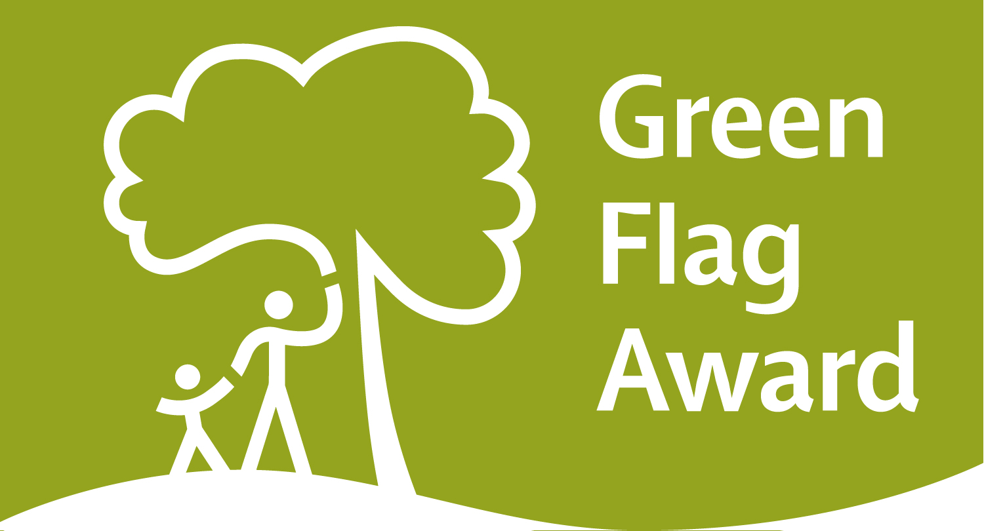 Green Flag Award Mystery Shop Assessment
Name of Site |  |  |  |  |  |  | Managing organisation
Weather Conditions
Date of assessment |  |  |  |  |  |  | Time  (from – to)
Result:  (✓) | Is the site of Green Flag Award Standard?  Green Amber Red
Grading |  |  |  |  |  | Comments and Recommendations
Please mark each section as  Green, Amber or Red  If there is no evidence or the section is not applicable mark as NG (not graded) and provide an explanation |  |  |  |  |  | Comments should be provided to support each grading  *Please include photographs to support your grading where applicable  **Please refer to Raising the Standard manual if necessary
A Welcoming Place
1. Is the site welcoming? |  | NG | G | A | R
2. Is the site easy to find? |  | NG | G | A | R
3. Is signage in good condition? |  | NG | G | A | R
4. Is the site accessible to all users? |  | NG | G | A | R
Healthy, Safe and Secure
5. Are facilities on site in good and safe condition? |  | NG | G | A | R
6. Did you feel safe during the visit? |  | NG | G | A | R
7. Are dogs being controlled and the site free of dog fouling? |  | NG | G | A | R
Well Maintained and Clean
8. Is litter, waste and recycling managed? |  | NG | G | A | R
9. Is there a good standard of horticulture maintenance? |  | NG | G | A | R

10. Is there a good standard of arboriculture maintenance? | NG | G | A | R
11. Are buildings and infrastructure such as walls, paths, steps and structures in good condition? | NG | G | A | R
12. Is equipment used by the public and staff in good condition? | NG | G | A | R
Environmental Management
13. Is there evidence that the site is managed to have a positive impact on the environment? | NG | G | A | R
Landscape and Heritage
14. Are heritage and/or landscape features in good condition? | NG | G | A | R
Community Involvement
15. Is there evidence of community involvement and engagement? | NG | G | A | R
16. Is user feedback positive? | NG | G | A | R
Marketing and Communication
17. Is there evidence of marketing and promotion, including events? e.g. notice boards, in buildings, website & social media. | NG | G | A | R
18. Is the correct year flag flying and certificate on display? | NG | G | A | R
Overall Result  (✓) | Is the site of Green Flag Award Standard?  Green Amber Red
Additional comments:

Insert photographic evidence below and on subsequent pages

