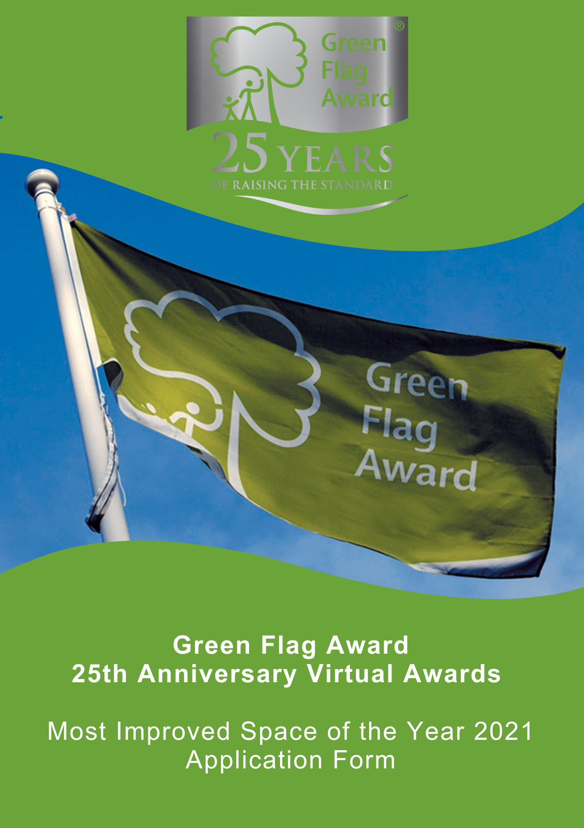

The Green Flag Award Scheme is the International standard for parks and green spaces. The Scheme is delivered in the UK by Keep Britain Tidy, Keep Northern Ireland Beautiful, Keep Scotland Beautiful and Keep Wales Tidy.
2021 marks the 25th anniversary of the Green Flag Award scheme, and in celebration of this occasion we are hosting a virtual award ceremony in November 2021.
Nominees will be shortlisted in October 2021 and the winner will be announced during the virtual award ceremony, date TBC.

Award Category: Most Improved Space of the Year 2021
Eligibility
Any one of the Green Flag Award or Green Flag Community Award winning sites in the UK can apply for this award. The application must be submitted by the management team of the space.
The ‘space’ must reside within the accredited park, but can be confined to one area of the park.
Criteria
The following criteria will be considered by the selection panel:
- The change within the space as evidenced by before and after photography
- New innovations and ideas for the space
- The value for money of the improvement
- The identification of needs and benefits delivered by the improvement will be considered
- The sustainability, scalability and replicability of the initiative will be considered
- Nominations must be submitted electronically and address the criteria for the award. Organisations may nominate more than one initiative.
Applicants must agree to any media publicity and promotion associated with the award as requested by The Green Flag Award Scheme and or Keep Britain Tidy and their partners.

Selection Panel
Applications will be assessed by an independent selection panel chaired by the Green Flag Award Team.
The judges reserve the right not to confer an award.
Award
The panel will award a winner, or in a tie, may award joint winners of the award. In exceptional circumstances the panel may confer a special commendation.
Feedback
The selection panel will provide feedback for the winner of the award. No feedback will be provided to unsuccessful applications
If you would like to send us supporting evidence such as reference materials, photos, screen grabs or press cuttings, please send these with the completed application form to greenflagawards@keepbritaintidy.org
CLOSING DATE FOR ENTRIES: Wednesday 22nd September (1pm)

Part One:
Project and applicant Information
Name and contact details of person completing the application

Name of Green Flag Award site

Date the space began being improved and the date the space was live to the public

Please complete each of the sections below, using maximum 500 words per section and identify any supporting evidence you are submitting.

Part Two:
Application Details
Please describe the space, the condition and how it was used before the improvement?
(Maximum 500 words, please identify any supporting evidence you are submitting.)

How was the space improved? Why and what was the cost?
(Maximum 500 words, please identify any supporting evidence you are submitting.)

Describe what impact and benefit the initiative made to the community.
(Maximum 500 words, please identify any supporting evidence you are submitting.)

Approximately how many members of the community benefitted from the initiative?
(Maximum 500 words, please identify any supporting evidence you are submitting.)

Thank you for submitting your application.

